7.16.3 Blackline Master

Equations
Matching Equations with Graphs  $$f(x)={(x-1)}^{2}+4$$ | Matching Equations with Graphs  $$g(x)={-(x-4)}^{2}+1$$
Matching Equations with Graphs  $$h(x)={(x+1)}^{2}-4$$ | Matching Equations with Graphs  $$p(x)=-{(x+1)}^{2}-4$$
Matching Equations with Graphs  $$q(x)=2{(x-4)}^{2}+1$$ | Matching Equations with Graphs  $$r(x)={(x+4)}^{2}-1$$

Graphs
Matching Equations with Graphs  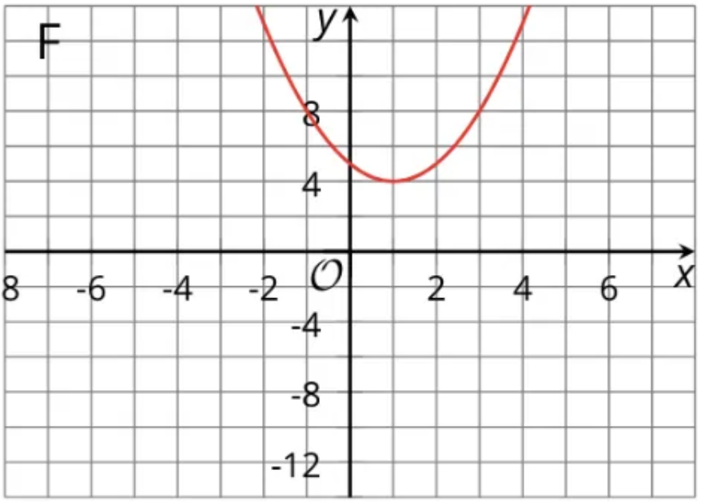 | Matching Equations with Graphs  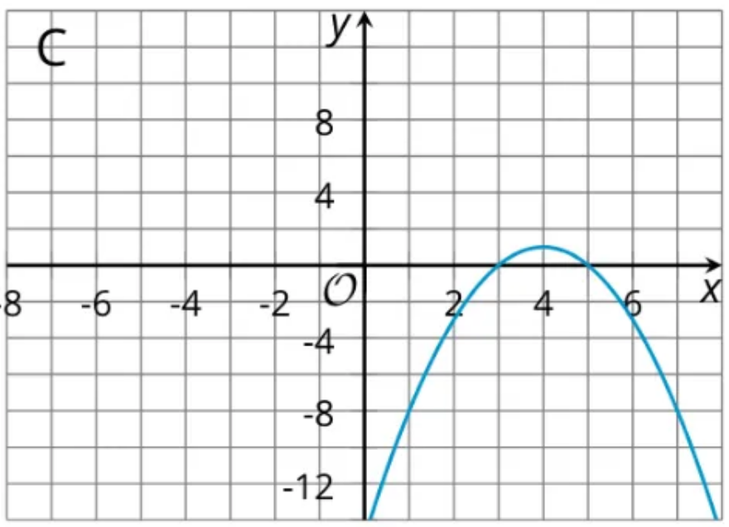
Matching Equations with Graphs  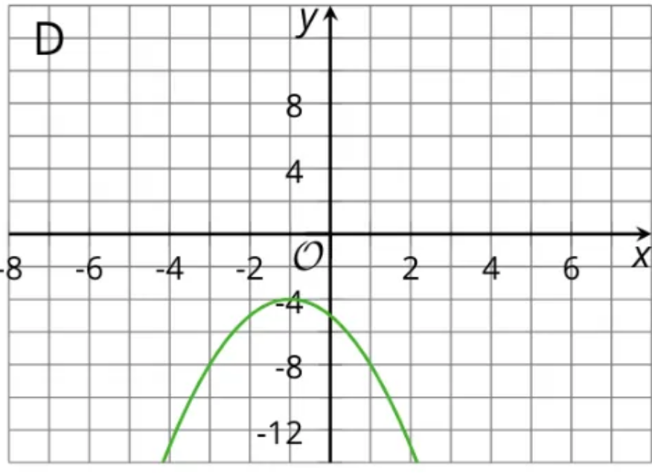 | Matching Equations with Graphs  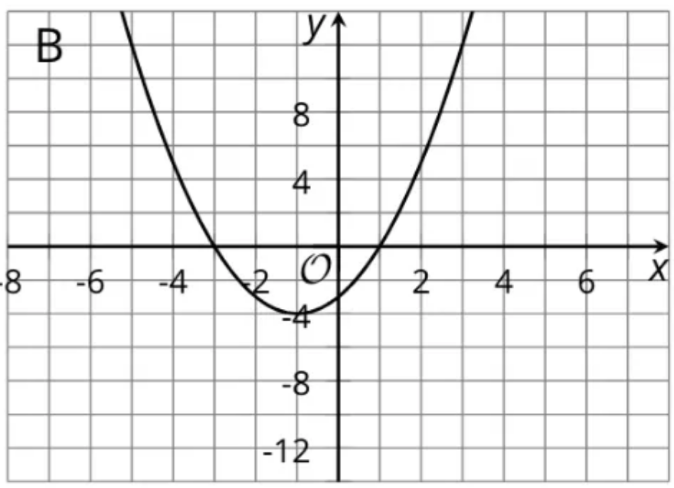
Matching Equations with Graphs  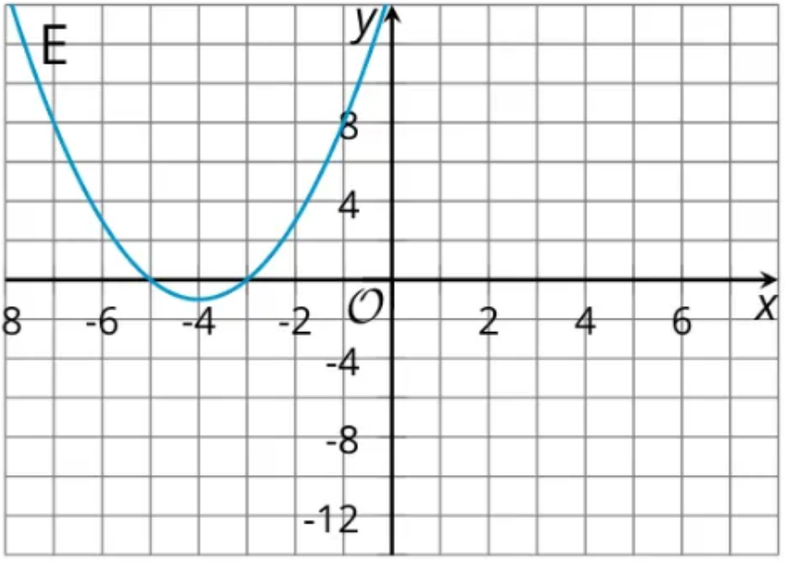 | Matching Equations with Graphs  